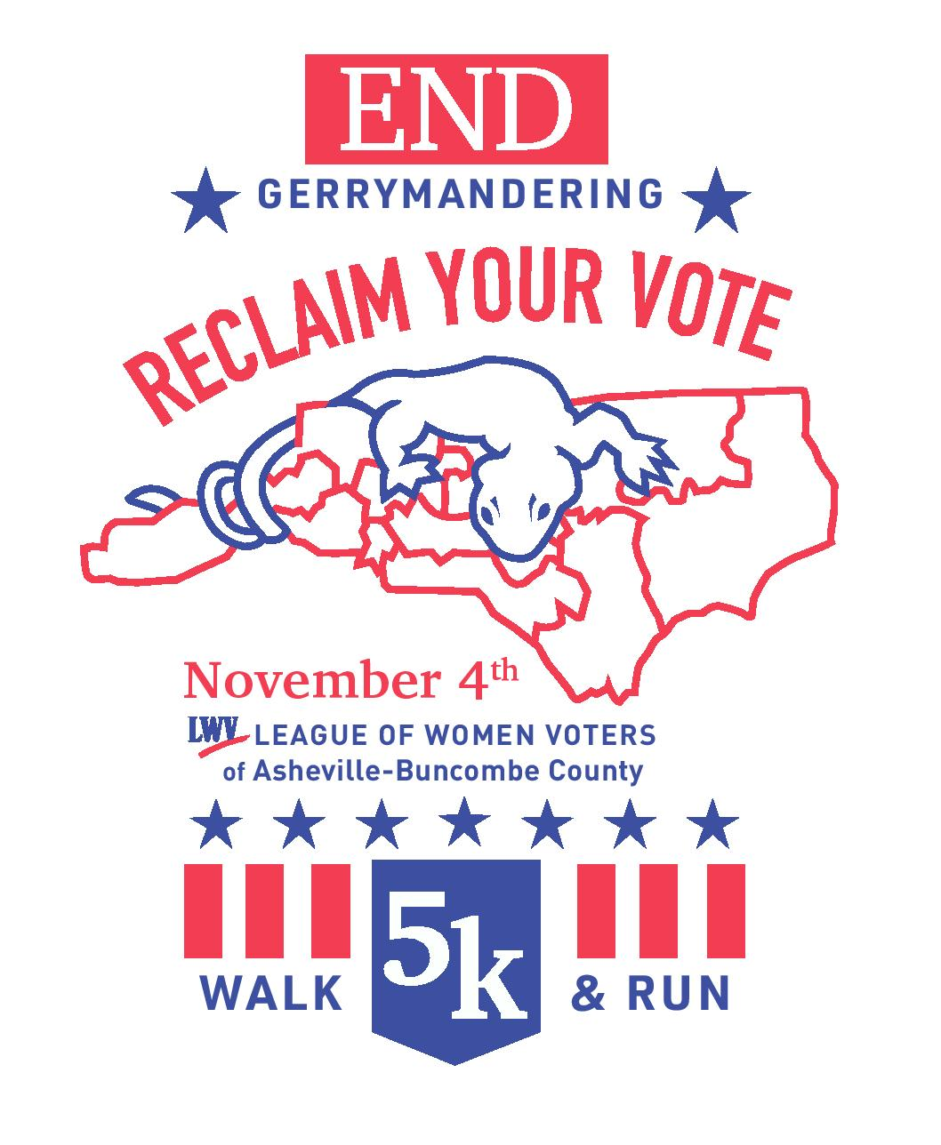

**Walk the Gerrymandered Line!**

The Gerrymander 5k is a walk/run along the **line dividing District 10 & 11 in West Asheville** to **advocate for a non-partisan redistricting committee**. The League of Women Voters has filed **5 lawsuits** since the NC legislature redrew the districts in 2011 and SCOTUS has affirmed that NC districts have been racially gerrymandered. **It is time for a change!**

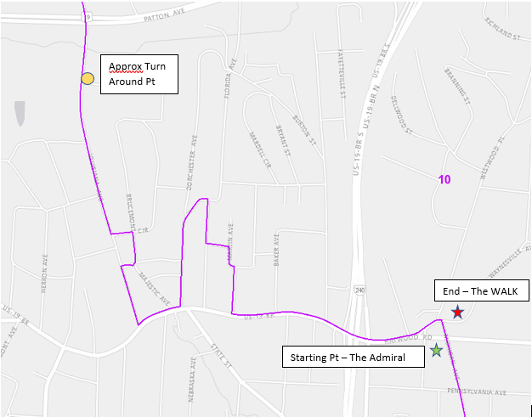

Even more crazy!

I wonder who lives there?

That’s crazy!

**What Is Gerrymandering?**

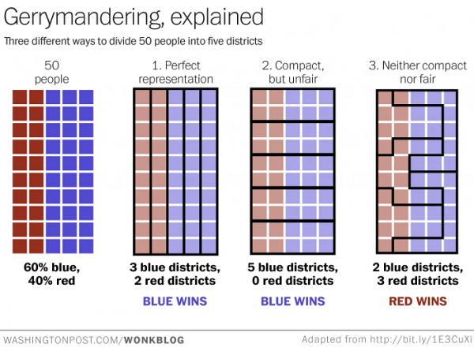Dividing a territorial unit into election districts **to give one political party an electoral majority** in a large number of districts **while concentrating the opposition in as few districts as possible**. Gerrymandering is legal; however, racial and extreme partisan gerrymandering are not. The NC state legislature is responsible for drawing district maps after every census and it is customary that the party in power draws map boundaries in order to benefit themselves. **New software map-drawing and data-driven voter analysis methods have created “gerrymandering on steroids,”** enabling the party in charge to pinpoint and isolate opposition voters.

**Why Care?**

Gerrymandering **greatly reduces officeholder accountability** to the voters because they are in safe districts. 40% of the 2016 state legislative races had NO OPPOSITION in the general election. It means **voters do not have a real choice**, so politicians don’t have to compete for their votes. **Competition is absolutely essential for democracy** and gerrymandering is a prime suspect in the cause of political/electoral gridlock. It **eliminates moderate ideology**, and can **facilitate extreme agendas**--the passing of House Bill 2 is just one example of this.

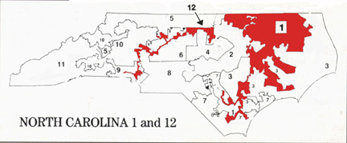**When: November 4, 2017**

**Time: 1:00 pm - 3:00 pm**

**Where: West Asheville along District 10 & 11**

**Start: The Admiral Parking Lot**

**End: The WALK** (including after party)

**Media Plan**

The Asheville-Buncombe League will be coordinating with Leagues around the state and on a national level for media coverage and simultaneous events. This is an awareness campaign meant to grab the attention of the public nationwide. These are just some of the media outlets we will be reaching out to.

**Online**

BlogHer

FiveThirtyEight

POLITICO

ProPublica

Slate.com

**Television**

ABC News

CBS News

FOX News Channel

NBC News

Telemundo

**Radio**

National Public Radio

WRES

WNCW

WLOS

WFAE (Charlotte)

**Print**

Atlanta Journal Constitution

Black Mountain News

Citizen-Times

Hola Carolina

Mountain Xpress

New York Times

Reuters

USA Today

Washington Post

WNC Woman

**Sponsorship Opportunities**



Sponsorship is about **associating your business** with an important issue and **being an active citizen**. In return for your investment in the Gerrymander 5k, your organization will have opportunities to:

* Be one of many to stand against diluting votes and stand for a non-partisan solution
* Be exposed to statewide and national media
* Showcase your organization in a new and innovative way

**Current Congressional Districts in WNC**

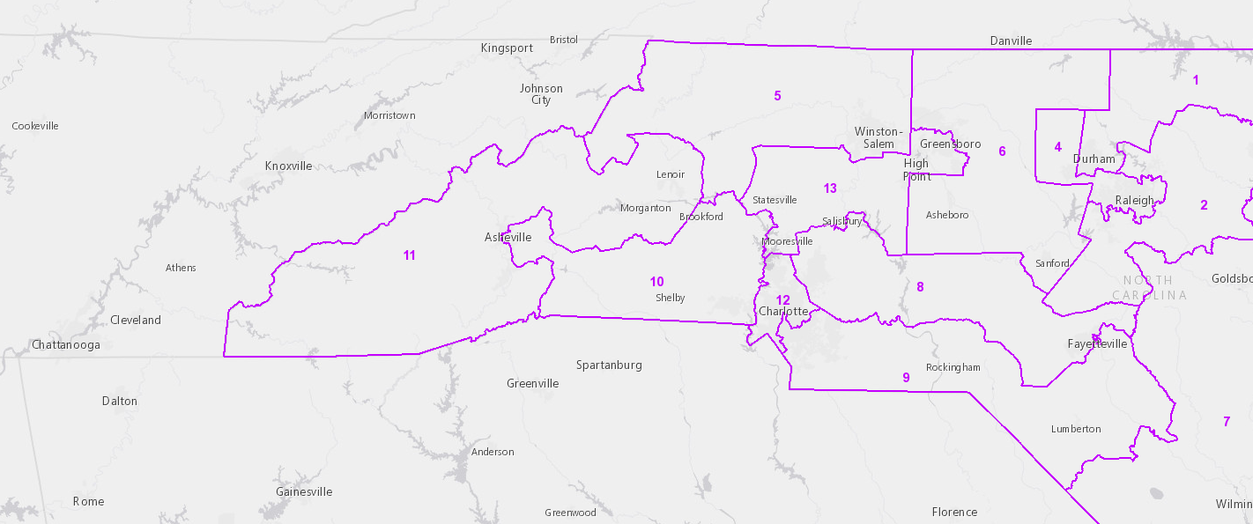

**Sponsorship Commitment**

**Business Name: ___________________________________________________________________**

**Contact Person: ___________________________________________________________________**

**Address: ___________________________________________________________________________**

**Phone: ______________________________ Email: ______________________________________**

**Sponsorship Level (circle one): Bronze ($250)    Silver ($500)    Gold ($750)    Platinum ($1000)**

**Other $____________________________**

**For tax-deductible contribution, please make checks payable to:**

***Florence Ryan Education Fund***

**PLEASE MAIL CHECK TO:**

**League of Women Voters Asheville Buncombe County**

**P.O. Box 8292**

**Asheville, NC 28814**

***Thank You for Your Contribution!***

